Jenkins Lab 1: Build a Simple CI/CD Pipeline
Beginner
60–90 minutes
Practical assignment
This lab is a good follow-up to the first class. Students will create their first Jenkins Pipeline using a Jenkinsfile, understand stages, and simulate a basic CI/CD workflow without needing a real application or production server.

1. Lab scenario
You are a junior DevOps engineer. Your development team wants a Jenkins pipeline that performs the following tasks automatically:
- Checks out or prepares application source code.
- Builds the application.
- Runs basic tests.
- Simulates deployment to a test environment.
Objective: Create a Jenkins Pipeline named Day2-CICD-Pipeline with four stages: Checkout, Build, Test, and Deploy.

2. Prerequisites
- Jenkins is installed and accessible.
- Students can log in to Jenkins.
- Basic knowledge of Linux commands.
- The Pipeline plugin is available.

3. Step 1 — Create a Pipeline project
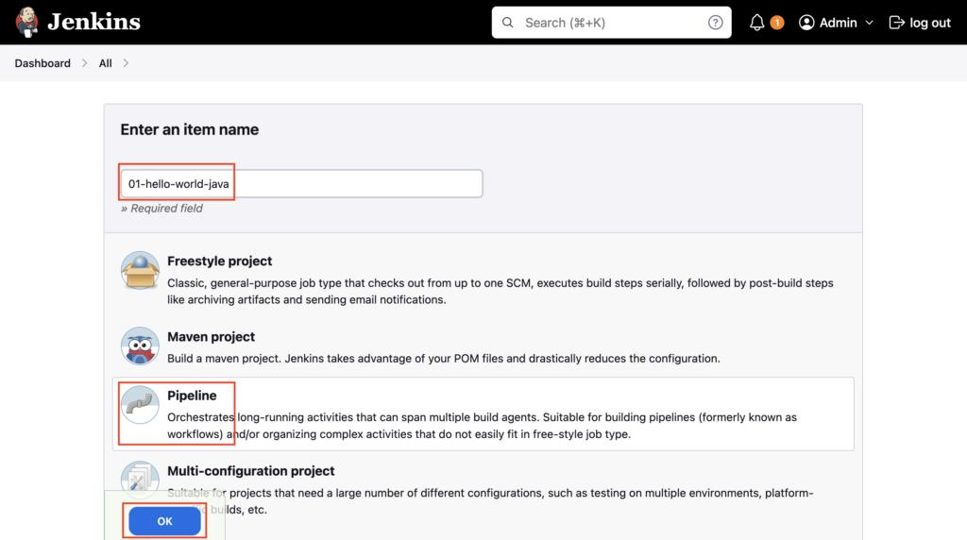
docs.devopspilot.com
Ask students to:
- Open the Jenkins dashboard.
- Click New Item.
- Enter Day2-CICD-Pipeline.
- Select Pipeline.
- Click OK.
- Scroll to the Pipeline section.
- Under Definition, select Pipeline script.

4. Step 2 — Write the Jenkinsfile
Ask students to paste this script into the Pipeline script editor.

pipeline {
agent any

stages {
stage('Checkout') {
steps {
echo 'Checking out application source code...'
sh 'mkdir -p app'
sh 'echo "Hello from Jenkins CI/CD Lab" > app/index.html'
sh 'ls -l app'
}
}

stage('Build') {
steps {
echo 'Building the application...'
sh 'test -f app/index.html'
sh 'echo "Build completed successfully"'
}
}

stage('Test') {
steps {
echo 'Running application tests...'
sh 'grep -q "Hello from Jenkins" app/index.html'
sh 'echo "All tests passed!"'
}
}

stage('Deploy') {
steps {
echo 'Deploying to the test environment...'
sh 'mkdir -p deployment'
sh 'cp app/index.html deployment/index.html'
sh 'cat deployment/index.html'
echo 'Deployment simulation completed!'
}
}
}

post {
success {
echo 'CI/CD Pipeline completed successfully!'
}

failure {
echo 'Pipeline failed. Check the logs.'
}

always {
echo 'Pipeline execution finished.'
}
}
}
Important: This is a simulated deployment. It copies a sample HTML file into a workspace directory; it does not deploy to a real server.

5. Step 3 — Execute the pipeline
- Click Save.
- Click Build Now.
- Open the build from Build History.
- Click Console Output.
- Verify that all four stages complete successfully.
Expected pipeline flow:
1. Checkout
Prepare sample source code
2. Build
Verify the application file
3. Test
Check expected application text
4. Deploy
Copy the file to deployment/
Expected console output will contain messages similar to:
Checking out application source code...
Building the application...
Running application tests...
All tests passed!
Deploying to the test environment...
Hello from Jenkins CI/CD Lab
CI/CD Pipeline completed successfully!
Pipeline execution finished.
Finished: SUCCESS
The build number, timestamps, and additional Jenkins log messages will vary.

6. Step 4 — Introduce a pipeline failure
This is the most important exercise for teaching troubleshooting.
Ask students to modify the Test stage by changing the expected text:
sh 'grep -q "INVALID_TEXT" app/index.html'
Then:
- Save the pipeline.
- Click Build Now.
- Observe the result of the Test stage.
- Open Console Output and identify the failed command.
- Explain why the Deploy stage did not run.
- Restore the original test command and execute the pipeline again.
Expected learning: a failed test stops subsequent stages by default, and the post block's failure and always sections still execute as applicable.

